

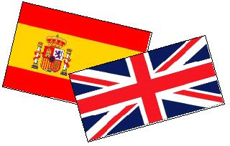

CALENDARIO ESCOLAR 2024-2025


Septiembre 2024
L | M | X | J | V | S | D
 |  |  |  |  |  | 1
2 | 3 | 4 | 5 | 6 | 7 | 8
9 | 10 | 11 | 12 | 13 | 14 | 15
16 | 17 | 18 | 19 | 20 | 21 | 22
23/30 | 24 | 25 | 26 | 27 | 28 | 29

Enero 2025
L | M | X | J | V | S | D
 |  | 1 | 2 | 3 | 4 | 5
6 | 7 | 8 | 9 | 10 | 11 | 12
13 | 14 | 15 | 16 | 17 | 18 | 19
20 | 21 | 22 | 23 | 24 | 25 | 26
27 | 28 | 29 | 30 | 31


Abril 2025
L | M | X | J |  | V | S | D
 | 1 | 2 | 3 |  | 4 | 5 | 6
7 | 8 | 9 | 10 |  | 11 | 12 | 13
14 | 15 | 16 | 17 |  | 18 | 19 | 20
21 | 22 | 23 | 24 |  | 25 | 26 | 27
28 | 29 | 30



Octubre 2024
L | M | X | J | V | S | D
 | 1 | 2 | 3 | 4 | 5 | 6
7 | 8 | 9 | 10 | 11 | 12 | 13
14 | 15 | 16 | 17 | 18 | 19 | 20
21 | 22 | 23 | 24 | 25 | 26 | 27
28 | 29 | 30 | 31

Febrero 2025
L | M | X | J | V | S | D
 |  |  |  |  | 1 | 2
3 | 4 | 5 | 6 | 7 | 8 | 9
10 | 11 | 12 | 13 | 14 | 15 | 16
17 | 18 | 19 | 20 | 21 | 22 | 23
24 | 25 | 26 | 27 | 28

Mayo 2025
L | M | X | J | V | S | D
 |  |  | 1 | 2 | 3 | 4
5 | 6 | 7 | 8 | 9 | 10 | 11
12 | 13 | 14 | 15 | 16 | 17 | 18
19 | 20 | 21 | 22 | 23 | 24 | 25
26 | 27 | 28 | 29 | 30 | 31
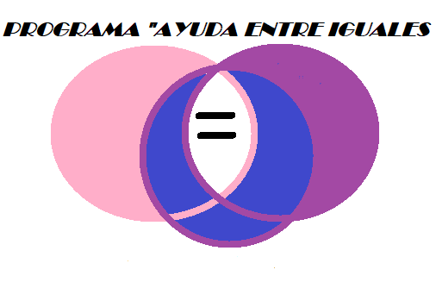

Noviembre 2024
L | M | X | J | V | S | D
 |  |  |  | 1 | 2 | 3
4 | 5 | 6 | 7 | 8 | 9 | 10
11 | 12 | 13 | 14 | 15 | 16 | 17
18 | 19 | 20 | 21 | 22 | 23 | 24
25 | 26 | 27 | 28 | 29 | 30

Marzo 2025
L | M | X | J | V | S | D
 |  |  |  |  | 1 | 2
3 | 4 | 5 | 6 | 7 | 8 | 9
10 | 11 | 12 | 13 | 14 | 15 | 16
17 | 18 | 19 | 20 | 21 | 22 | 23
24/31 | 25 | 26 | 27 | 28 | 29 | 30

Junio 2025
L | M | X | J | V | S | D
 |  |  |  |  |  | 1
2 | 3 | 4 | 5 | 6 | 7 | 8
9 | 10 | 11 | 12 | 13 | 14 | 15
16 | 17 | 18 | 19 | 20 | 21 | 22
23 | 24 | 25 | 26 | 27 | 28 | 29


Diciembre 2024
L | M | X | J | V | S | D
 |  |  |  |  |  | 1
2 | 3 | 4 | 5 | 6 | 7 | 8
9 | 10 | 11 | 12 | 13 | 14 | 15
16 | 17 | 18 | 19 | 20 | 21 | 22
23/30 | 24/31 | 25 | 26 | 27 | 28 | 29

Festivos y celebraciones pedagógicas
SEP |  | 11 Comienzo del curso
NOV |  | 1 Día de todos los Santos  25 Día del Docente
DIC |  | 6 y 9 Día de la Constitución
ENE |  | 30 Día de la Paz
MAR |  | 3 y 4 Carnaval
ABRIL |  | 22 al 25 Semana Cultural
MAYO |  | 1 y 2 Día del trabajo
JUNIO |  | 20 Fin de curso
 | FESTIVOS Y VACACIONES
 | FIN DE SEMANA
 | SESIONES CCP
 | SESIONES EVALUACIÓN
 | ENTREGA DE NOTAS
 | DÍA DEL CENTRO

