CORRECCIONES 16 DE JUNIO

MATES:
- 5,859
- 5,605
- 13,9944

- 9,4
- 74
- 2,23

INGLES:
- Prueba de control tema 8:

- Complete:
Take a shower: Tomar una ducha / baño
Use recargables batteries: Usar baterías recargables.
Reuse plastic bags: Reutilizar bolsas de plástico
Collect rubbish: Recoger basura
Use public transport: Utilizar transporte público
Turn off the lights: Apagar las luces.
Recycle paper: Reciclar papel.
Recycle bottles: Reciclar botellas.

- Translate:
Yo reutilizo las bolsas de plástico del supermercado.
I reuse plastic bags of the supermarcket.
Ella apaga la luz de su habitación a las siete en punto.
She turns of the lights of her bedroom at seven o’clock.
Mis amigos no usan el transporte público para viajar a la ciudad.
My friends don´t use public transport to travel to the town.
Nosotros recogemos la basura del camping con el profesor.
We collect the rubbish of the camping with the teacher.

- Complete:
Un poco: a little
Algunos/as: a few
Suficiente: plenty of
Bastante: enought

- Read and complete with the words of exercise 3: (Lee y completa con las palabras del ejercicio 3)
There are a few things we can do to save resources.
There is enought traffic where I live.
There is plenty of food we can put in the freezer.
There is a little of cofee on the table.
Not enought people use public transport.

- Listen and write a little or a few: (Escucha las palabras y escribe el cuantificador correcto para cada una)
- a little
- a few
- a few
- a little

- Look at the pictures and write a setence: (Mira las imágenes y escribe una oración) RESPUESTAS MÚLTIPLES.
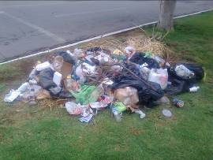

The lorry collects rubbish of the streets every day.


All my classmates reuse paper in the school.

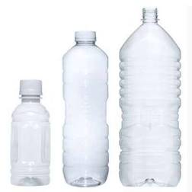

My mother recycles bottles to make crafts.

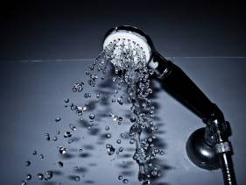
Your brother takes a shower in the gym.

- Complete:
Donar comida: donate food.
Salvar árboles: save trees.
Reducir contaminación: reduce pollution.
Ahorrar energía: save energy
Mantener el planeta limpio: keep the planet clean
Reducir residuos: reduce waste
Compartir coche: car pool
Ahorrar recursos: save resources

- Complete the table of irregular verbs:
INFINITIVE | PAST SIMPLE | PAST PARTICIPLE | SPANISH
be | Was / were | Been | Ser, estar
break | Broke | Broken | Romper
come | Came | Come | Venir
do | Did | Done | Hacer
can | Could | Been able | Poder
eat | Ate | Eaten | Comer
find | Found | Found | Encontrar
go | Went | Gone | Ir
buy | Bought | Bought | Comprar
feel | Felt | Felt | Sentir

- Translate:
Si tú usas el transporte público, reducirás la contaminación.
If you use public transport, you will reduce pollution.
Ahorraremos energía si apagamos las luces en casa.
We will save energy, if we turn off the lights at home.
Si tú reciclas todos los días, mantendrás el planeta limpio.
If you recycle every day, you will keep the planet clean.
Salvaremos los árboles, si reutilizamos el papel en clase.
We will save trees, if we reuse paper in the classroom.

- Translate:
Billions of tonnes (toneladas) of rubbish are produce by humans every year. Drik cans (latas), plastic bottles and plastic bags are a big problem. They accumulate on land and in rivers and oceans, and kill many animals. We have to reduce plastic and metal we use, reuse what we can and recycle the rest.
Billones de toneladas de basura son producidas por los humanos cada año. Las latas de bebida, las botellas y bolsas de plástico son un gran problema. Ellas se acumulan en la tierra y en los ríos y océanos, y matan a muchos animales. Nosotros tenemos que reducir el plástico y el metal que usamos, reutilizar lo que podamos y reciclar el resto.

