ENGLISH EXAM – TOPIC 8
THE ENVIRONMENT - 6º PE

Name: _________________________________________
Date: ___________________

- Complete:
Take a shower. ___________________ Use recargables batteries: _____________
Reuse plastic bags: _________________ Collect rubbish: _________________
Use public transport_________________ Turn off the lights: ____________________
Recycle paper: ______________________
Recycle bottles: ______________________

- Translate:
Yo reutilizo las bolsas de plástico del supermercado.
_______________________________________________________
Ella apaga la luz de su habitación a las siete en punto.
_______________________________________________________
Mis amigos no usan el transporte público para viajar a la ciudad.
_______________________________________________________
Nosotros recogemos la basura del camping con el profesor.
_______________________________________________________

- Complete:
Un poco: __________________
Algunos/as: ___________________
Suficiente: __________________
Bastante: ___________________
- Read and complete with the words of exercise 3: (Lee y completa con las palabras del ejercicio 3)
There are ______________ things we can do to save resources.
There is ______________ traffic where I live.
There is _____________ food we can put in the freezer.
There is _____________ cofee on the table.
Not _____________ people use public transport.

- Listen and write a little or a few: (Escucha las palabras y escribe el cuantificador correcto para cada una)
- _______
- _______
- _______
- _______

- Look at the pictures and write a setence: (Mira las imágenes y escribe una oración)
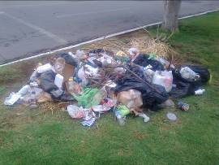

__________________________________________________


__________________________________________________

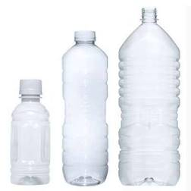

___________________________________________________


___________________________________________________

- Complete:
Donar comida: ___________________
Salvar árboles: ____________________
Reducir contaminación: _________________________
Ahorrar energía: _________________________
Mantener el planeta limpio: _____________________________
Reducir residuos: _____________________________
Compartir coche: ___________________________
Ahorrar recursos: ______________________________

- Complete the table of irregular verbs:
INFINITIVE | PAST SIMPLE | PAST PARTICIPLE | SPANISH
be

break
come
do
can
eat
find
go
buy
feel

- Translate:
Si tú usas el transporte público, reducirás la contaminación.
_____________________________________________________________
Ahorraremos energía si apagamos las luces en casa.
_____________________________________________________________

Si tú reciclas todos los días, mantendrás el planeta limpio.
_____________________________________________________________
Salvaremos los árboles, si reutilizamos el papel en clase.
______________________________________________________________

- Translate:
Billions of tonnes (toneladas) of rubbish are produce by humans every year. Drik cans (latas), plastic bottles and plastic bags are a big problem. They accumulate on land and in rivers and oceans, and kill many animals. We have to reduce plastic and metal we use, reuse what we can and recycle the rest.
____________________________________________________________________
____________________________________________________________________
____________________________________________________________________
____________________________________________________________________
____________________________________________________________________
____________________________________________________________________
____________________________________________________________________
____________________________________________________________________
____________________________________________________________________
____________________________________________________________________

